### More Queries On Insurance Database

**1.List The Entire Participated Relation In The Descending Order Of Damage Amount.**

**Query :** select * from PARTICIPATED_081 order by damage_amount desc;

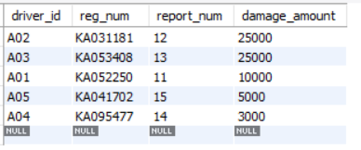

**2.** **Find The Average Damage Amount**

Query : select avg(damage_amount) from PARTICIPATED_081;

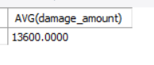

**3.List The Name Of Driver Whose Damage Is Greater Than The Average Damage Amount.**

Query : select name from PERSON_081, PARTICIPATED_081 where PERSON_081.driver_id = PARTICIPATED_081.driver_id and PARTICIPATED_081.damage_amount > (select avg(damage_amount) from PARTICIPATED _081

